New Computer Language Coding Concepts

Interface System Command Calls
The concepts of system command call notations is not explained here. Refer to the System Command Call Notations article in the System Objects chapter for that. this is a supplement to that documentation, covering it for the Interface aspect. The Interface Merged aspect is also covered.

Cross-aspect situations can apply to the Interface aspect, but they are not covered. Cross-aspect situations between the Object and Class aspects are described in the System Objects chapter and adequately shed light on the topic.

Interface – System Interface - Command Call Notation
Only one example of a call to a system command of the Interface aspect using the system interface notation will be given here. Below you will find this notation for a call to the Object-Interface Get command:

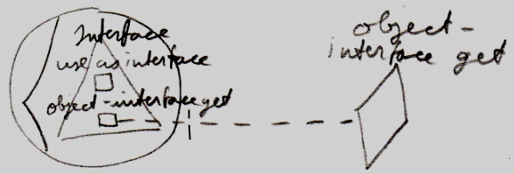

Simplified System Command Call Notation
Below you will find the various types of calls to a system command on the Interface aspect in the simplified system command call notation.

Use As Interface | Use Reference As Interface
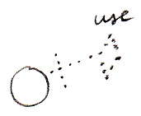 | 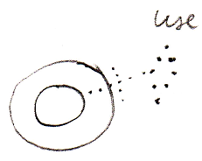
Interface Set
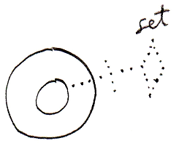
Object-Interface Get | Reference-Interface Get
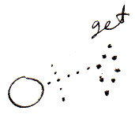 | 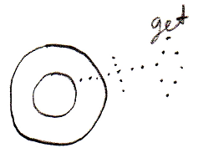
Interface Merged Get | Interface Merged Set
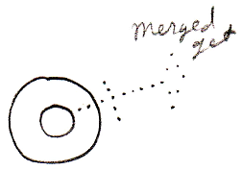 | 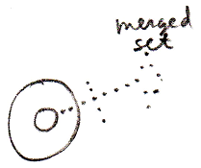

System Command Call Notation with Argument
Below you will find the various types of calls to a system command on the Interface aspect in the system command call with argument notation.

Use As Interface | Use Reference As Interface | Interface Set
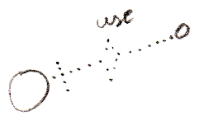 | 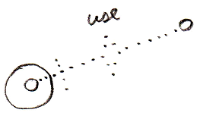 | 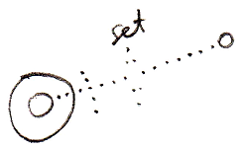
Use As Interface ←  (Interface Set →) | Use Reference As Interface ←  (Interface Set →) | (Interface Get →)  Interface Set ←
Object-Interface Get | Reference-Interface Get
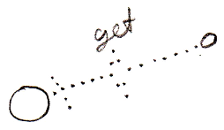 | 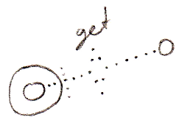
Object-Interface Get ←  (Interface Set →) | Reference-Interface Get ←  (Interface Set →)

Interface Merged Get | Interface Merged Set
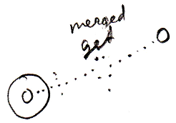 | 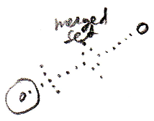
Interface Merged Get ←  (Value Set →) | (Value Get →)  Interface Merged Set ←

(For the Interface Merged commands the argument is a Boolean.)

Explicit Get & Set Notation
Below you will find some examples of the explicit Get and Set notation working on the Interface aspect.

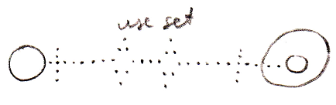

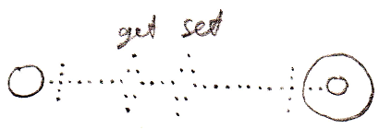

Explicit Get & Set Arguments Notation
Below you find various notations where Get and Set arguments are explicitly drawn out, in which the Interface aspect is adressed.

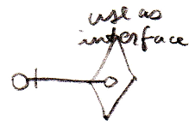

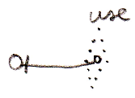

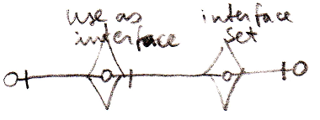

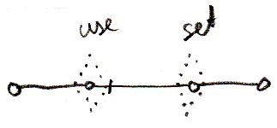

Author & Copyright: Jan-Joost van Zon Date: May 7, 2010 – May 7, 2010 Location: Oosterhout, The Netherlands Status: Finished

